# Background

We are seeking proposals from local people, communities, organizations, and programs that are working to address health and racial inequity in Dane County. Health equity looks like everyone having a fair and just shot at optimal health. Proposals should address the [root causes](https://hria.org/2021/04/20/rootcauses/) of health inequities. The Healthy Communities Fund is part of our commitment to [antiracism and community collaboration](https://publichealthmdc.com/documents/core_values.pdf).

### Funding and proposal review

A total of $14,000 is available. Past projects that have received funding have been in the range of $1,000 - $5,000. A list of previously funded proposals is linked here.

Funds are flexible and can be used for anything that helps you promote health equity in Dane County. This funding is open to new and existing projects and programs, including the operations of groups or agencies. Higher preference and scores will be given to proposals for projects which:

* Are supporting new or expanding efforts aimed at improving health equity
* Clearly explain how these funds are critical to the outcome or success of your proposal
* Benefit areas or populations impacted by systemic marginalization
* Applicant has an existing relationship with this group

Proposals must take place completely within Dane County, WI during 2025. We will follow up with awardees during the funding period for an update on the project. There will be no formal reporting requirements.

Funded proposals will need to complete a W-9 and Vendor Letter with the City of Madison Finance Department in order to receive funds.

### Healthy Communities Fund Timeline

|  |  |
| --- | --- |
| September 13, 2024 | Application window opens |
| October 8, 2024 | Last day to request verbal application time slot |
| October 1-16, 2024, Mon-Fri 8 am - 4 pm | Verbal application interviews completed over Zoom |
| October 16, 2024 | Applications due |
| No later than November 15, 2024 | Applicants informed of funding decisions |
| No later than December 31, 2023 | Funds dispersed to awardees |

### Application Questions

**Contact Information**

|  |  |
| --- | --- |
| Submitting Organization, group, or individual | Click or tap here to enter text. |
| Street address | Click or tap here to enter text. |
| City, State, Zip Code | Click or tap here to enter text. |
| Name of Contact | Click or tap here to enter text. |
| Email | Click or tap here to enter text. |
| Phone Number | Click or tap here to enter text. |

Is your proposed project based in Dane County, Wisconsin?

YES NO

Funded proposals will need to complete a W-9 and Vendor Letter with the City of Madison Finance Department to receive funds. If funded, are you able to complete this process?

YES NO

Contacts for funded proposals need to be in communication with our staff at the start and end of the funding cycle. We will use information shared to highlight impact stories and discuss project progress, as well as to create relationships for future collaboration. If funded, are you willing to be in communication with our staff?

YES NO

**Application Details**

|  |  |
| --- | --- |
| Name of Project/Program/Initiative | Click or tap here to enter text. |
| Amount requested | Click or tap here to enter text. |
| Anticipated start date | Click or tap here to enter text. |
| Anticipated completion date | Click or tap here to enter text. |

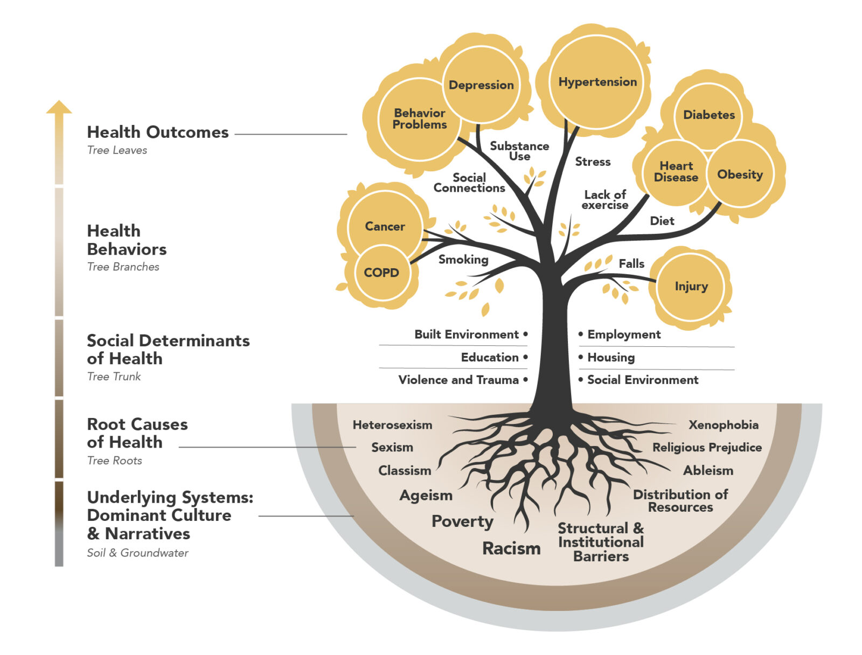

Which root cause of health inequity does your proposal most closely align with? (Choose as many as apply)

Reducing inequities in specific groups:

☐ Race and/or ethnicity

☐ Gender

☐ Ability

☐ Immigration status

☐ Sexual orientation and/or gender expression

☐ Other intersections/dimensions of identity

Reducing inequities related to:

☐ Education

☐ Employment

☐ Health systems and services

☐ Housing

☐ Wealth Accumulation/Income

☐ Public safety and legal protection

☐ Access to clean air, water, green space

☐ Food systems or hunger

☐ Transportation

☐ Other

Please tell us about what you will use these funds to do. Short phrases or sentences are fine—you don’t need to write long paragraphs

1. Brief description of project(s) (in a sentence or two).

Click or tap here to enter text.

1. Briefly, tells us how much money you are requesting and what you plan to spend it on. Please be clear if this is supporting or expanding something that is established or is proposing to start something new.

Click or tap here to enter text.

1. Briefly, tells us what you hope will happen because of your proposal? How is this funding critical to the success of your proposal or the outcome you would like to see?

Click or tap here to enter text.

1. In a sentence or two, or with a map, please describe where (geographic area/neighborhood) and/or with who (community/group) will you focus your effort?

Click or tap here to enter text.

1. Do you have an existing relationship with the community, group, or area?

YES NO

1. If yes, please describe this relationship in a sentence or two. If you need to build this connection, please describe how you plan to do so.

Click or tap here to enter text.